Project Title
Recommendation Engine
Project Report submitted for the partial fulfilment of grade for the course
Data Structures and Algorithms -3 (25CS2103E)
in
A.Y. 2026-2027
Submitted by
Venkat Sai (2520090034)
Yaswanth (2520080048)
Team Number:
Section: 10
Under the guidance of
Mrs. K. Chandusha
Assistant Professor, CSIT

Hyderabad-500090, Telangana, India.

K L (Deemed to be) University
DEPARTMENT OF COMPUTER SCIENCE ENGINEERING / COMPUTER SCIENCE AND INFORMATION TECHNOLOGY/ARTIFICIAL INTELLIGENCE & DATA SCIENCE

DECLARATION
The Mini Project Report entitled "Recommendation Engine" is a record of Bonafide work of Venkat Sai – 2520090034, Yaswanth – 2520080048 submitted in partial fulfillment for the award of B. Tech in Computer Science and Information Technology/ Artificial Intelligence & Data Science to the K L University. The results embodied in this report have not been copied from any other departments/University/Institute.
Venkat Sai – 2520090034
Yaswanth – 2520080048

K L (Deemed to be) University
DEPARTMENT OF COMPUTER SCIENCE AND INFORMATION TECHNOLOGY
CERTIFICATE
This is to certify that the mini project based report entitled "Recommendation Engine" is a bonafide work done and submitted by Venkat Sai – 2520090034, Yaswanth – 2520080048 in partial fulfillment of the requirements for the award of the degree of BACHELOR OF TECHNOLOGY in Department of Computer Science and Information Technology/Artificial Intelligence & Data Science, K L (Deemed to be University), during the academic year 2026-2027.
Signature of the Supervisor
Signature of the HOD Signature of the External Examiner

ACKNOWLEDGEMENT
The success of this project would not have been possible without the timely help and guidance rendered by many people. We wish to express our sincere thanks to all those who have assisted us in one way or the other in the completion of our project.
Our greatest appreciation goes to our guide, Mrs. K. Chandusha, assistant professor, CSIT, for her tremendous support, encouragement and guidance throughout this project, which cannot be expressed in words.
We express our gratitude to Dr. Khaja Shareef (CSIT) / Dr. Sreenath Itikela (AI&DS), Head of the Department of Computer Science Engineering / Department of Computer Science and Information Technology / Department of Artificial Intelligence and Data Science for providing us with adequate facilities, ways and means by which we were able to complete this project-based lab.
We thank all the members of the teaching and non-teaching staff who have assisted us directly or indirectly in the successful completion of this project. Finally, we sincerely thank our parents, friends and classmates for their kind help and cooperation during our work.

Venkat Sai – 2520090034
Yaswanth – 2520080048

TABLE OF CONTENTS
S.No. | Contents | Page no.
1. | Abstract | 6
2. | Introduction | 7
3. | Literature survey | 8
4. | Problem Statement and Objectives | 10
5. | Hardware and Software requirements | 11
6. | Implementation | 12
7. | Results & Discussion | 16
8. | Conclusion & Future Scope | 18
9. | References | 19

1. ABSTRACT
The Movie Recommendation Engine Using Data Structures and Algorithms is designed to provide personalized movie recommendations by analyzing user preferences, movie genres, ratings, and viewing history. The system maintains an efficient index of users and movies using appropriate data structures such as Hash Maps and Array Lists, enabling fast retrieval and processing of information. A scoring mechanism evaluates the relevance of each movie based on user interests, ratings, genre similarity, and popularity. The recommended movies are ranked using efficient sorting techniques and displayed as the top suggestions for each user.
To improve recommendation quality, the system applies diversity rules to avoid repetitive recommendations from the same genre and provide a balanced selection of movies. The project demonstrates the practical application of core DSA concepts including searching, sorting, hashing, priority queues, and ranking algorithms, while ensuring efficient performance. It provides an interactive and user-friendly interface that helps users discover movies that match their interests, making it a practical real-world application of data structures and algorithms in modern entertainment platforms.
Team Members:
- Venkat Sai, 2520090034
- Yaswanth, 2520080048
Guide: Mrs. K. Chandusha
Section: 10

2. INTRODUCTION
With the rapid growth of streaming platforms, users are presented with thousands of movies across many genres. Choosing what to watch has become time-consuming, and users often face information overload. Recommendation engines address this by filtering the catalogue and presenting only the titles most likely to interest a particular user. Platforms such as Netflix, Amazon Prime Video and YouTube depend heavily on such systems to keep users engaged.
Most research on recommenders concentrates on machine learning models. This project takes a different route: it builds the recommender from first principles using core data structures and algorithms covered in the Data Structures and Algorithms-3 course. User ratings and movie details are stored in Hash Maps, giving average O(1) lookup. Genre indices and rating lists are kept in Array Lists. A weighted relevance score is computed for every unseen movie, and a Min-Heap (priority queue) selects the Top-N candidates in O(M log N) time, which avoids sorting the whole catalogue. Finally, a diversity filter re-ranks the shortlist so that no single genre dominates the output.
The main aspects of the project are:
- What: a personalised Top-10 movie recommender built with hashing, searching, sorting and priority queues.
- Why: to reduce information overload and show how classical DSA concepts solve a real-world problem efficiently.
- How: index data in Hash Maps, score each candidate, rank with a Min-Heap, and re-rank with a diversity rule.
The rest of this report covers the literature survey, problem statement and objectives, hardware and software requirements, implementation, results and discussion, and finally the conclusion and future scope.

3. LITERATURE SURVEY
The following existing systems and studies on recommendation were reviewed. Their URLs are listed in the References section.
1. MovieLens Recommender Datasets (GroupLens): A widely used benchmark of user–movie ratings collected by the University of Minnesota. It is the standard dataset for evaluating recommendation algorithms, and it inspired the structure of the user–movie–rating data used in this project.
2. Netflix Prize Competition: A public competition that challenged teams to improve Netflix's rating prediction accuracy by 10%. It popularised collaborative filtering and matrix factorization and showed the commercial value of recommendation.
3. Item-Based Collaborative Filtering (Sarwar et al.): Computes similarity between items from user rating patterns and recommends items similar to those a user liked. It scales better than user-based methods, but needs pre-computed similarity tables.
4. Amazon Item-to-Item Collaborative Filtering (Linden et al.): Amazon's production recommender that matches each purchased item to similar items instead of matching similar customers, giving real-time recommendations on very large catalogues.
5. Matrix Factorization Techniques (Koren et al.): Represents users and items as latent-factor vectors and predicts ratings by their dot product. Accurate, but harder to interpret and computationally heavier than index-based methods.
6. Surprise – Python Recommender Library: An open-source Python toolkit with SVD, KNN and baseline algorithms for explicit-rating data. Useful for experimentation; this project instead implements the logic manually with DSA.
7. Apache Mahout: A scalable machine-learning library offering distributed collaborative filtering. Suited to big-data settings, but with a large framework overhead compared with a lightweight in-memory engine.
8. LensKit for Python: A research toolkit for building and evaluating recommender systems, with ranking-based evaluation metrics. It informed our Top-N ranking approach.
9. Python heapq (Priority Queue) Module: Provides the binary heap implementation used for Top-N selection. Keeping a heap of size N gives O(M log N) selection instead of the O(M log M) cost of a full sort.
10. scikit-learn Content-Based Methods: Offers TF-IDF and cosine-similarity tools for content-based filtering that match item attributes with a user profile. Our genre-similarity component follows the same idea with simpler hash-based profiles.
Approaches in the literature fall into three groups: Collaborative Filtering (finds patterns across similar users), Content-Based Filtering (matches item attributes such as genres and keywords against a user's history) and the DSA-Optimised Approach used in this project, which uses fast-lookup Hash Maps and Min-Heaps to cut computational overhead and keep response times low in real time, even for new users with little history.

4. PROBLEM STATEMENT AND OBJECTIVES
Problem Statement: To design an efficient movie recommendation engine that suggests relevant and diverse movies to users using data structures and algorithms.
Problem Description: Users face information overload on streaming platforms and need a fast system that ranks unseen movies by their personal preferences while avoiding repetitive, single-genre results.
Objectives:
- To store user ratings and movie information in Hash Maps and Array Lists for fast indexing and retrieval.
- To compute a relevance score for each unseen movie using user rating history, genre similarity and popularity.
- To select and rank the Top 10 movies efficiently using a Min-Heap (priority queue) and sorting techniques.
- To apply a diversity filter that stops recommendations from being dominated by a single genre.
- To provide an interactive interface for recommendation, movie search and genre browsing.
- To demonstrate practical applications of searching, sorting, hashing and priority queues, and analyse their time complexity.

5. HARDWARE AND SOFTWARE REQUIREMENTS
Hardware Requirements:
- CPU: Intel Core i5 / AMD Ryzen 5 or higher
- RAM: 8 GB DDR4 (for in-memory index storage)
- Display: 1080p Standard Full HD monitor
- Storage: 256 GB NVMe SSD for fast I/O throughput
Software Requirements:
Category | Specification Details
Operating System | Windows 10/11, macOS, or Linux (Ubuntu 20.04+)
Programming Language | Java (JDK 17+) or Python 3.10+
Development IDE | IntelliJ IDEA / VS Code / PyCharm
Libraries & Modules | NumPy, Pandas, Scikit-Learn (for data manipulation)

6. IMPLEMENTATION
The system follows a four-stage pipeline: (1) Indexing and Scoring, where user interactions are indexed using Hash Maps for O(1) average lookup, and (2) Top-N Ranking and Diversity, where the best candidates are chosen using a Min-Heap and re-ranked by a diversity filter. The relevance score of a movie m for user u is:
Score(u, m) = 0.5 × GenreSimilarity(u, m) + 0.3 × (AvgRating(m) / 5) + 0.2 × (Popularity(m) / MaxPopularity)
where GenreSimilarity is the mean normalised rating the user has given to the genres of m, AvgRating is the movie's mean rating, and Popularity is the number of ratings it has received. These weights can be changed to apply dynamic weighting for individual preferences. The code is written in Python 3 and is organised into four modules.
Module 1: Data Indexing using Hash Maps and Array Lists
class DataStore:
def __init__(self):
self.movies = {} # movie_id -> {title, genres, year}
self.user_ratings = defaultdict(dict) # user_id -> {movie_id: rating}
self.movie_ratings = defaultdict(list) # movie_id -> [ratings]
self.genre_index = defaultdict(list) # genre -> [movie_ids]

def add_movie(self, mid, title, genres, year):
self.movies[mid] = {"title": title, "genres": genres, "year": year}
for g in genres:
self.genre_index[g].append(mid)

def add_rating(self, uid, mid, rating):
self.user_ratings[uid][mid] = rating
self.movie_ratings[mid].append(rating)

def avg_rating(self, mid):
r = self.movie_ratings.get(mid, [])
return sum(r) / len(r) if r else 0.0

def popularity(self, mid):
return len(self.movie_ratings.get(mid, []))

def search(self, keyword):
keyword = keyword.lower()
return [m for m, d in self.movies.items() if keyword in d["title"].lower()]
Module 2: Relevance Scoring
W_GENRE, W_RATING, W_POP = 0.5, 0.3, 0.2

def build_profile(store, uid):
"""Genre preference vector: average rating given by the user per genre."""
totals, counts = defaultdict(float), defaultdict(int)
for mid, r in store.user_ratings[uid].items():
for g in store.movies[mid]["genres"]:
totals[g] += r
counts[g] += 1
return {g: totals[g] / counts[g] / 5.0 for g in totals} # normalised 0..1

def score_movie(store, profile, mid, max_pop):
genres = store.movies[mid]["genres"]
genre_sim = sum(profile.get(g, 0) for g in genres) / len(genres)
rating = store.avg_rating(mid) / 5.0
pop = store.popularity(mid) / max_pop if max_pop else 0
return W_GENRE * genre_sim + W_RATING * rating + W_POP * pop
Module 3: Top-N Ranking using Min-Heap and Diversity Filter
def top_n(scored, n):
"""Keep the n best items using a min-heap -> O(M log n)."""
heap = []
for score, mid in scored:
if len(heap) < n:
heapq.heappush(heap, (score, mid))
elif score > heap[0][0]:
heapq.heapreplace(heap, (score, mid))
return sorted(heap, reverse=True)

def diversify(store, ranked, n, max_per_genre=3):
"""Re-rank: no more than max_per_genre movies sharing the same primary genre."""
used, result = defaultdict(int), []
for score, mid in ranked:
g = store.movies[mid]["genres"][0]
if used[g] < max_per_genre:
result.append((score, mid))
used[g] += 1
if len(result) == n:
break
return result

def recommend(store, uid, n=10, max_per_genre=3):
profile = build_profile(store, uid)
seen = store.user_ratings[uid]
max_pop = max((store.popularity(m) for m in store.movies), default=1)
scored = [(score_movie(store, profile, m, max_pop), m)
for m in store.movies if m not in seen]
candidates = top_n(scored, n * 3) # larger pool for diversity re-ranking
return diversify(store, candidates, n, max_per_genre)
Module 4: Sample Dataset and Interactive Interface
def load_sample(store):
movies = [
(1,"Inception",["Sci-Fi","Thriller"],2010),(2,"The Dark Knight",["Action","Crime"],2008),
(3,"Interstellar",["Sci-Fi","Drama"],2014),(4,"The Matrix",["Sci-Fi","Action"],1999),
(5,"Avengers: Endgame",["Action","Sci-Fi"],2019),(6,"Mad Max: Fury Road",["Action","Adventure"],2015),
(7,"John Wick",["Action","Thriller"],2014),(8,"Gladiator",["Action","Drama"],2000),
(9,"The Godfather",["Crime","Drama"],1972),(10,"Pulp Fiction",["Crime","Drama"],1994),
(11,"Goodfellas",["Crime","Biography"],1990),(12,"The Shawshank Redemption",["Drama","Crime"],1994),
(13,"Forrest Gump",["Drama","Romance"],1994),(14,"Titanic",["Romance","Drama"],1997),
(15,"La La Land",["Romance","Musical"],2016),(16,"The Notebook",["Romance","Drama"],2004),
(17,"Superbad",["Comedy"],2007),(18,"The Hangover",["Comedy"],2009),
(19,"3 Idiots",["Comedy","Drama"],2009),(20,"Zindagi Na Milegi Dobara",["Comedy","Adventure"],2011),
(21,"Get Out",["Horror","Thriller"],2017),(22,"A Quiet Place",["Horror","Sci-Fi"],2018),
(23,"The Conjuring",["Horror","Mystery"],2013),(24,"Toy Story",["Animation","Comedy"],1995),
(25,"Spirited Away",["Animation","Fantasy"],2001),(26,"The Lion King",["Animation","Drama"],1994),
(27,"Lord of the Rings: Fellowship",["Fantasy","Adventure"],2001),(28,"Harry Potter 1",["Fantasy","Adventure"],2001),
(29,"Parasite",["Thriller","Drama"],2019),(30,"Se7en",["Crime","Thriller"],1995),
]
for m in movies: store.add_movie(*m)
ratings = {
101:{1:5,4:5,3:4,2:4,7:3,9:2,15:1},
102:{9:5,10:5,12:5,11:4,30:4,2:4,14:2,17:1},
103:{14:5,15:5,16:5,13:4,19:4,17:3,4:1},
104:{17:5,18:5,19:5,20:4,24:4,13:3,21:1},
105:{21:5,22:4,23:5,30:4,29:4,1:3,16:1},
106:{2:5,5:5,6:5,7:4,8:4,4:4,15:2},
107:{1:4,3:5,12:4,13:4,27:5,28:4,25:5},
108:{24:5,25:5,26:5,27:4,28:5,20:3,23:1},
}
for u, rs in ratings.items():
for m, r in rs.items(): store.add_rating(u, m, r)

def show(store, uid, n=10):
print(f"\nTop {n} recommendations for User {uid}")
print("-" * 66)
print(f"{'Rank':<5}{'Movie':<32}{'Genres':<22}{'Score':>5}")
for i, (s, m) in enumerate(recommend(store, uid, n), 1):
d = store.movies[m]
print(f"{i:<5}{d['title']:<32}{'/'.join(d['genres']):<22}{s:>5.2f}")

def main():
store = DataStore(); load_sample(store)
print("=== MOVIE RECOMMENDATION ENGINE ===")
print(f"Movies indexed: {len(store.movies)} | Users: {len(store.user_ratings)}")
while True:
print("\n1. Recommend 2. Search movie 3. Browse genre 4. Exit")
c = input("Choice: ").strip()
if c == "1":
show(store, int(input("User ID (101-108): ")))
elif c == "2":
for m in store.search(input("Keyword: ")):
print(" ", m, store.movies[m]["title"], f"(avg {store.avg_rating(m):.1f})")
elif c == "3":
g = input("Genre: ").title()
for m in store.genre_index.get(g, []): print(" ", store.movies[m]["title"])
elif c == "4":
break

if __name__ == "__main__":
main()
Time Complexity Summary
Operation | Data Structure | Complexity
Rating / movie lookup | Hash Map | O(1) average
Genre browsing | Hash Map + Array List | O(k)
Scoring all unseen movies | Hash Map | O(M × g)
Top-N selection | Min-Heap | O(M log N)
Diversity re-ranking | Hash Map counter | O(N)

7. RESULTS & DISCUSSION
The program was executed on a sample dataset of 30 movies and 8 users. The screenshots below show the output of each feature.
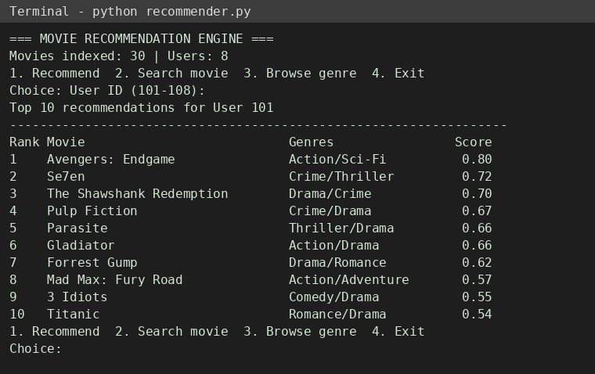
Fig 7.1: Top 10 recommendations for User 101
User 101 rates Sci-Fi and Action movies highly, so Avengers: Endgame is ranked first. Crime, Drama and Thriller titles follow, giving a mixed list instead of one genre repeated.
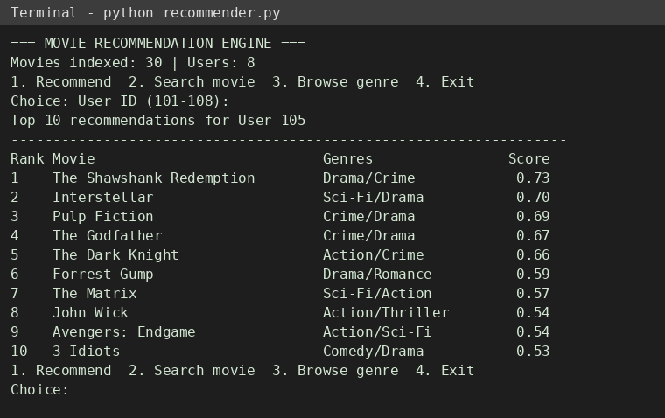
Fig 7.2: Top 10 recommendations for User 105
User 105 prefers Horror and Thriller but has already watched most of the top titles in those genres. Highly rated Drama and Crime movies are therefore recommended next, and the diversity filter limits any one primary genre to 3 movies.
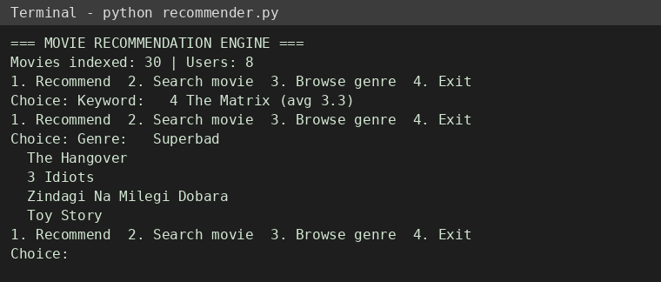
Fig 7.3: Movie search by keyword and genre browsing
Keyword search returns "The Matrix" with its average rating, and genre browsing lists all four Comedy titles instantly because both use Hash Map lookups.
Discussion
- Different users receive different Top-10 lists, showing that recommendations are personalised by their genre profile.
- Movies a user has already rated are excluded from the output.
- The Min-Heap keeps only N candidates, so selection cost grows with log N instead of the catalogue size.
- The diversity filter produced more balanced lists than plain score ranking.
- Since the engine uses only in-memory Hash Maps, it responds immediately on the sample dataset; the same design suits movies, e-commerce, books and online courses.

8. CONCLUSION & FUTURE SCOPE
Conclusion
The project met its objectives. A working Movie Recommendation Engine was built in which Hash Maps and Array Lists index users, movies and genres; a weighted scoring function measures relevance using genre similarity, ratings and popularity; a Min-Heap selects the Top 10 efficiently; and a diversity filter prevents one-genre results. The interactive interface supports recommendation, search and genre browsing. The project shows how classical data structures and algorithms can solve a practical information-overload problem with efficient performance.
Future Scope
- Near term: load a larger public dataset such as MovieLens, add a graphical or web interface, and add watch-history and time-based weighting.
- Medium term: add user-to-user and item-to-item collaborative filtering, trie-based search with auto-suggestion, and automatic tuning of scoring weights.
- Long term: combine the DSA engine with machine-learning models, deploy it as a scalable service, and extend it to e-commerce, books and online courses.

9. REFERENCES
1. GroupLens Research, "MovieLens Datasets." https://grouplens.org/datasets/movielens/
2. "Netflix Prize." https://en.wikipedia.org/wiki/Netflix_Prize
3. B. Sarwar et al., "Item-based collaborative filtering recommendation algorithms," WWW 2001. https://doi.org/10.1145/371920.372071
4. G. Linden, B. Smith, J. York, "Amazon.com recommendations: item-to-item collaborative filtering," IEEE Internet Computing, 2003. https://doi.org/10.1109/MIC.2003.1167344
5. Y. Koren, R. Bell, C. Volinsky, "Matrix factorization techniques for recommender systems," IEEE Computer, 2009. https://doi.org/10.1109/MC.2009.263
6. Surprise – A Python scikit for recommender systems. https://surpriselib.com/
7. Apache Mahout. https://mahout.apache.org/
8. LensKit for Python. https://lkpy.lenskit.org/
9. Python Documentation, "heapq – Heap queue algorithm." https://docs.python.org/3/library/heapq.html
10. scikit-learn, "Machine Learning in Python." https://scikit-learn.org/

